Top 10 Destinations in Siargao Island

1. Cloud 9 Surfing Area

R578+F36 Siargao Island, General Luna, Surigao del Norte

Open 24 hours

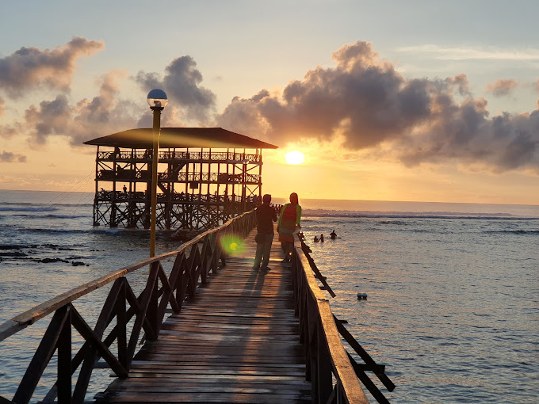

1. Sohoton Cove

Socorro, Surigao del Norte, Philippines

7:00 AM - 4:00 PM

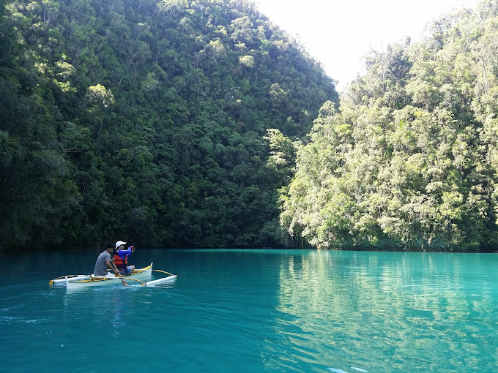

1. Magpupungko Rock Pools

Pilar

Open 24 hours

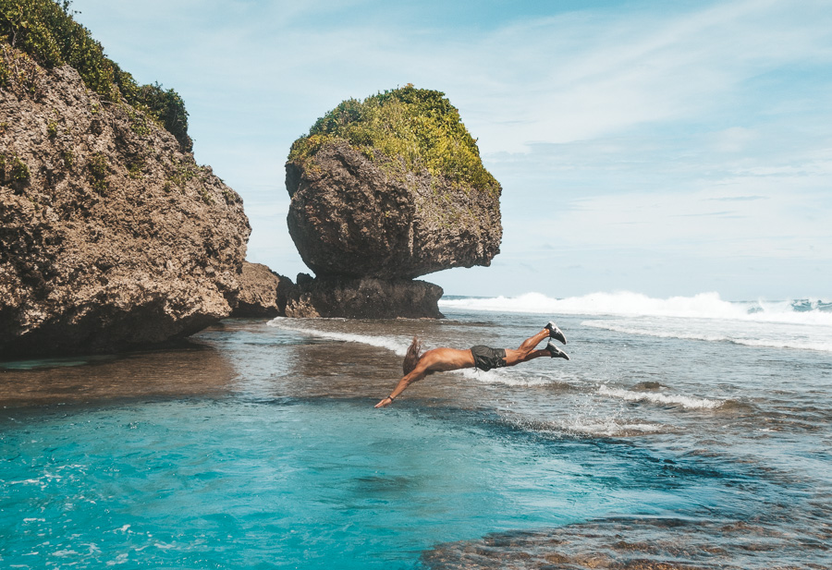

1. Sugba Lagoon

Del Carmen, Surigao del Norte

7 AM–5 PM

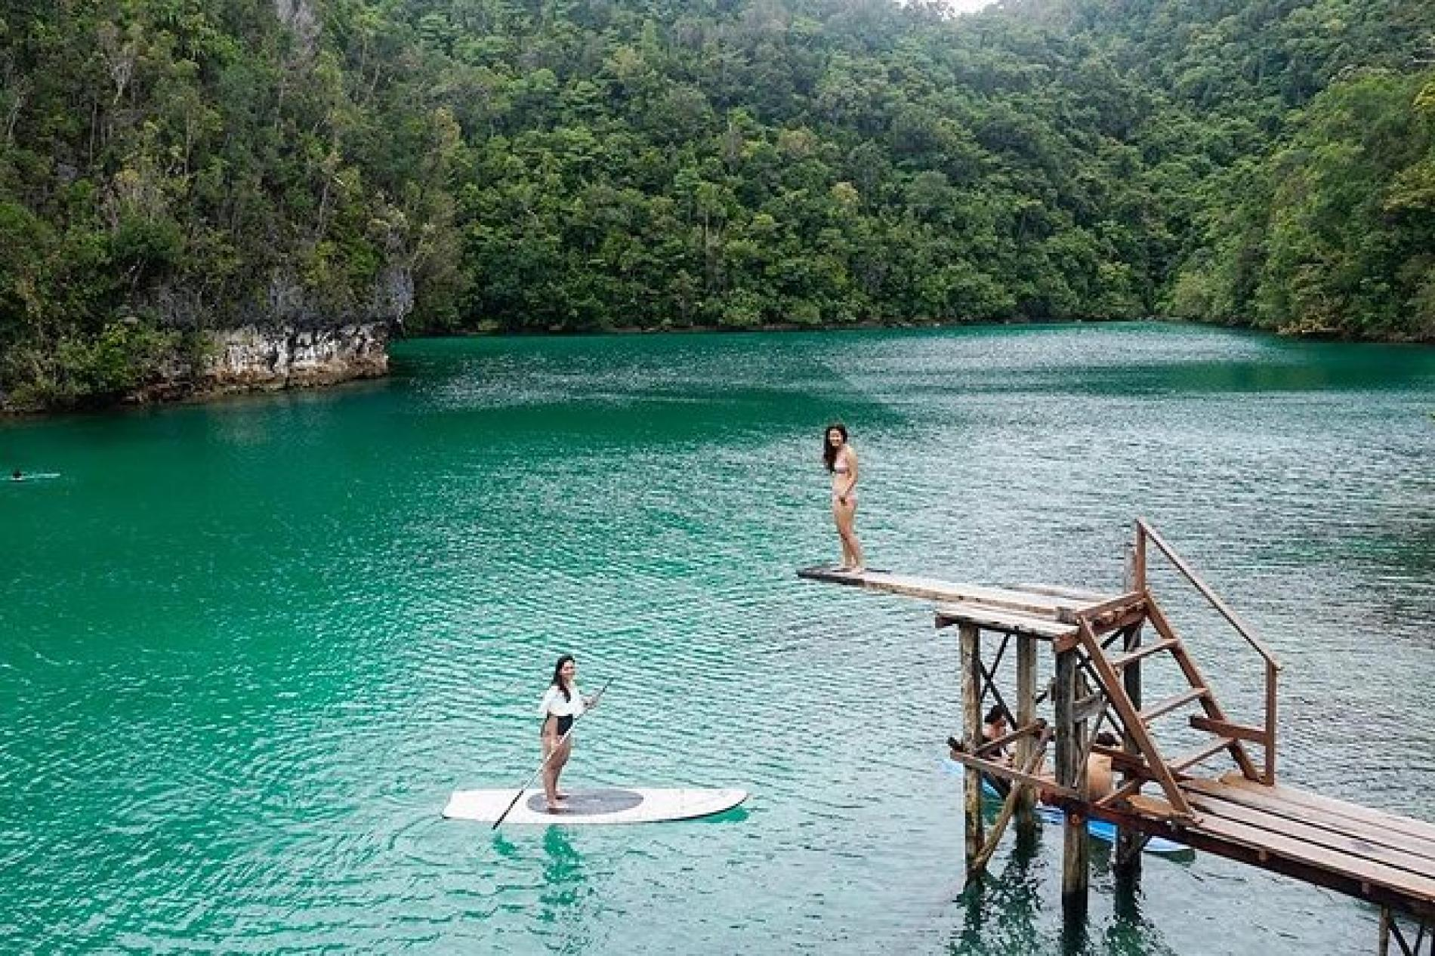

1. Guyam Island

General Luna

Open 24 hours

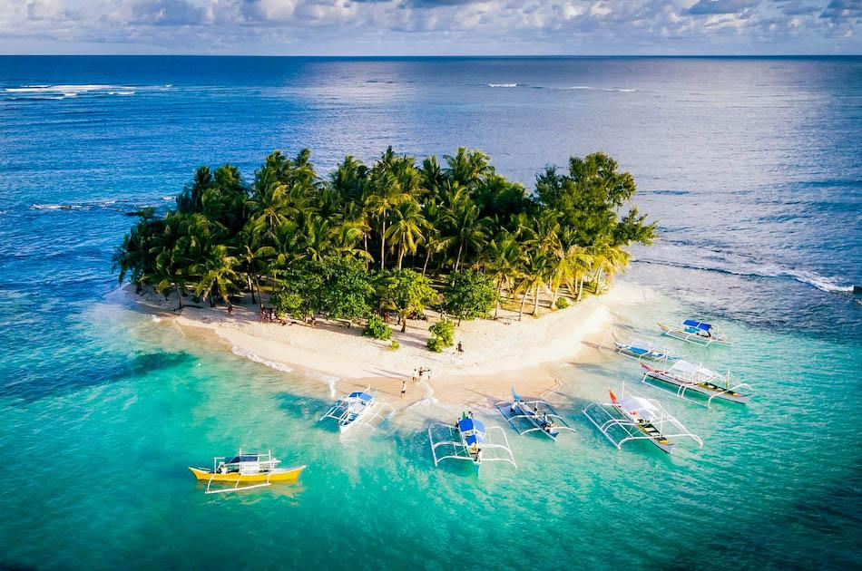

1. Daku Island

General Luna

Open 24 hours

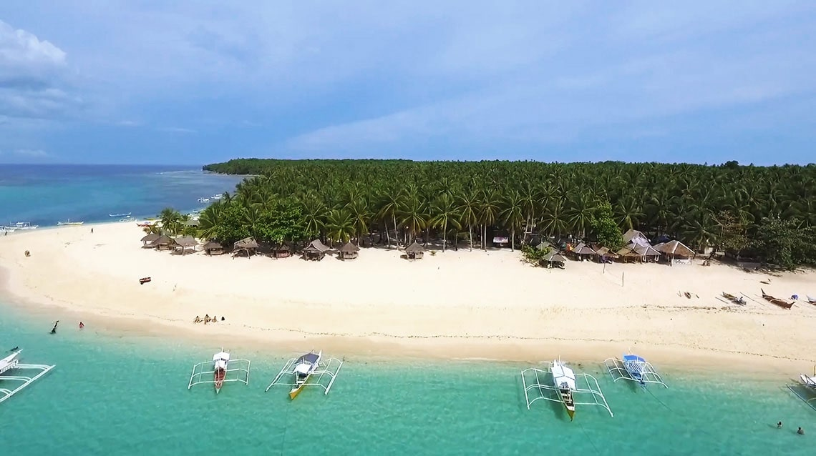

1. Taktak Falls

22MV+MCF, Santa Monica, Surigao del Norte

8:00 AM - 5:00 PM

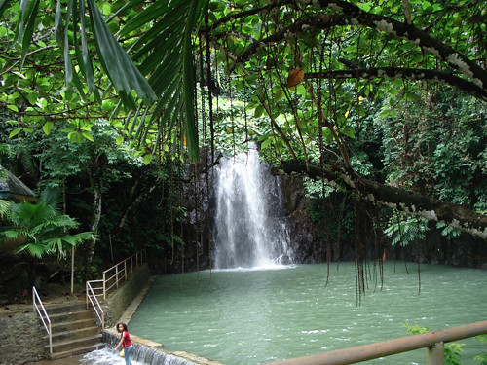

1. Maasin Bridge River Swing

R3C4+HFW, Siargao Circumferential Rd, Dapa, Surigao del Norte

7:30 AM–6 PM

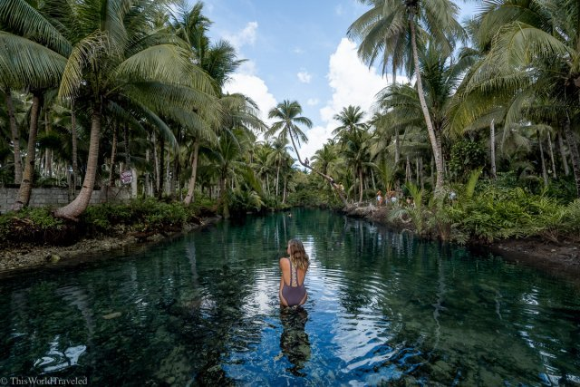

1. Naked Island

 P4MG+WCR, Siargao Island, Union Rd, Dapa, Surigao del Norte

Open 24 hours

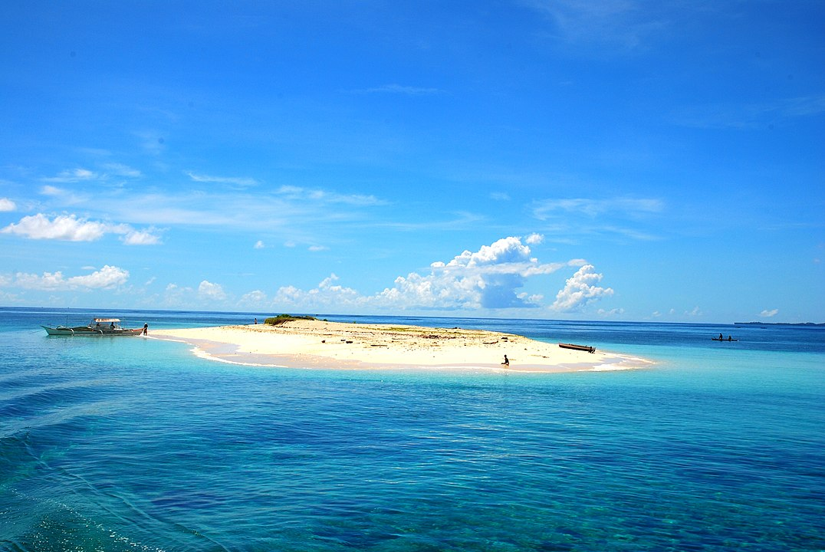

1. Coconut Tree Viewpoint

R366+V37, Siargao Circumferential Rd, Dapa, Surigao del Norte

7:30 AM–8:50 PM

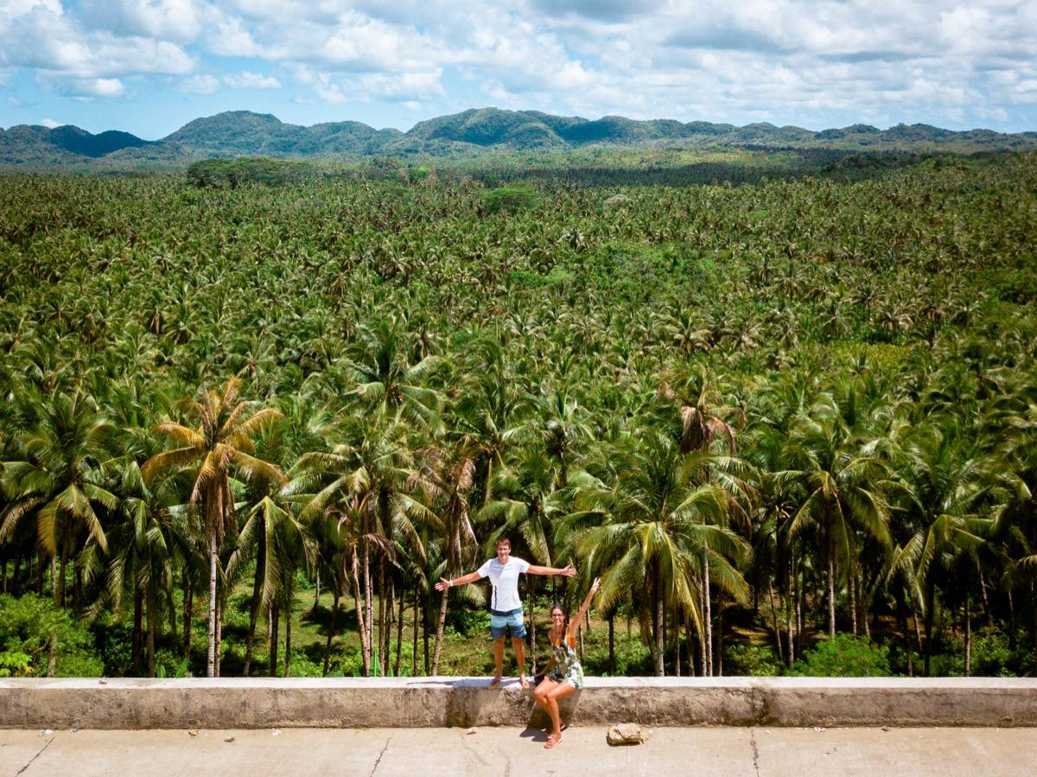

**General FAQs  
  
1. How to get to Siargao?**

To reach Siargao, book a domestic flight to Sayak Airport from Cebu. If you prefer a scenic route, you can optionally take a ferry from Surigao City. Once you arrive, make arrangements for local transportation to your accommodation.

**2. When is the best time to go to Siargao?**

It depends on what you’re looking for! September is by far the busiest month. The national & international surfing competitions and the town fiesta are all in September. If you’re looking for epic surf, the waves are best from September to November. If you’re looking for uncrowded surf, come from December to March. It’s uncrowded because it’s raining. A lot. If you want to learn how to surf, come anytime. If you have no idea why everyone keeps talking about surfing, then April to October are perfect for beach all day and party all night.

**3. What are the must-do activities in Siargao?**

In Siargao, you must surf at Cloud 9, go island hopping to Naked Island, Guyam Island, and Daku Island, explore Sugba Lagoon, visit the unique Magpupungko Rock Pools, and enjoy the vibrant nightlife in General Luna.

**4. Where to stay in Siargao?**

Popular areas to stay in Siargao include General Luna, Cloud 9, and nearby villages like Pacifico and Dapa. These areas offer a range of accommodations, from hostels to luxury resorts, to suit different budgets and preferences.

**5. How much does it cost to travel to Siargao?**

A budget traveler in Siargao might spend around 1,500 to 2,500 Philippine Pesos per day, while a mid-range traveler could budget for 2,500 to 5,000 Philippine Pesos per day. For luxury travelers, the daily expenses could exceed 5,000 Philippine Pesos. Domestic flights typically range from 7,500 to 16,000 Philippine Pesos round trip, depending on your departure location and booking timing.

**6. What is the currency in Siargao?**

The currency used in Siargao, Philippines, is the Philippine Peso (PHP).

**7. Is it safe to travel to Siargao?**

Siargao is generally safe for travelers. However, exercise common travel precautions, such as securing belongings and being mindful of the weather and sea conditions. Stay updated on any local advisories and health recommendations.

**8. What are the visa requirements for Siargao?**

Most tourists can enter the Philippines without a visa for 30 days. If needed, you can extend your stay. Check the latest visa rules and ensure your passport is valid for at least six months beyond your intended departure date.

**9. How can I get around in Siargao?**

You can get around Siargao by using tricycles, habal-habal (motorcycle taxis), rented scooters or bicycles, and vans or private vehicles.

**10. What is the weather like in Siargao?**

Siargaoo has a tropical climate with a wet season from November to February and a dry season from March to October. The best time to visit is during the dry season for sunny weather.

**SPECIFIC FAQs**

1. How to get there?

Fly to Siargao (IAO) airport. Take tricycle or van to General Luna. Take another tricycle or rent scooter to Cloud 9. Many accommodations are nearby.

From General Luna, travel to Dapa. Take a boat from Dapa to Sohoton Cove.

Fly to Siargao's Sayak Airport, then take a tricycle to General Luna. From there, hire a tricycle or motorcycle for a 40-45 minute ride to Magpupungko on bumpy roads.

Travel from General Luna to Del Carmen in Siargao. Take a tricycle, motorcycle, or other local transportation for about 30-45 minutes. Head to the port in Del Carmen and board a boat to Sugba Lagoon.

Fly to Siargao, then take a tricycle or other local transport to General Luna. Find a boat operator on the beach and book an island hopping tour to Guyam.

Fly to Siargao Airport and take a tricycle or other local transportation to General Luna. Find a boat operator on the beach and book an island hopping tour to Daku Island.

Get to Surigao Airport, then bus or hire vehicle to Santa Monica. In Santa Monica, hire tricycle or habal-habal to Taktak Falls.

Ride out General Luna, right onto the first main road. Continue to Coconut Mountain View Deck, then shortly after, look for the red Maasin bridge.

To visit Naked Island, join an island-hopping tour from General Luna, the tourist hub of Siargao.

The Coconut View Deck Siargao is a 25-minute ride from General Luna along the Siargao Circumferential Road. You're bound to pass it during your trip!

1. What should I expect for food?

Cloud 9 has laid-back surf cafes with local & international dishes, some focusing on healthy options for surfers.

Food options on your Sohoton Cove tour: picnic lunches, local cuisine, and snacks from vendors.

Near Magpupungko: simple Filipino dishes at local eateries/stalls or picnic lunches on tours.

Tour meals: local Filipino cuisine, picnic lunches, beachside dining.

Island-hopping tours offer Filipino cuisine: seafood, adobo, fruits, and rice. Menu varies by operator.

Daku Island locals might sell refreshing coconut water to complement your meal, often featuring fresh seafood like grilled fish and squid.

Bring your own food and drinks to Taktak Falls, but there might be local vendors too.

You might find food stalls near Maasin Bridge selling snacks and local fare. Availability varies.

Island-hopping tours often offer Filipino lunch: grilled seafood, adobo, fruits, rice. Naked Island lunch is picnic-style on the sand.

Tours often include meals with local Filipino cuisine. Coconut Tree Viewpoint might be a lunch stop.

1. What are the safety conditions?

* Be aware of weather and surfing risks, especially during typhoon season (June-November). Follow local guidelines and consider lessons if you're a beginner surfer.
* To ensure a safe trip to Sohoton Cove, choose reliable tours and wear life jackets for all water activities.
* Always check tide schedules and wear appropriate footwear when exploring Magpupungko's tidal pools. Consider joining guided tours for enhanced experience and safety. Be cautious of currents and swim in designated areas.
* Be aware of water depth and follow safety guidelines. Check weather forecasts and avoid visiting during storms.
* Join safe island-hopping tours and wear life jackets for water activities. Wear appropriate footwear for uneven terrain.
* Stay safe: Join guided tours, wear life jackets on water, and wear proper shoes on rough terrain.
* For a safe and enjoyable experience at Taktak Falls, consider guided tours, check weather before your visit, and be cautious while swimming.
* Be safe by checking safety instructions, using gear, joining tours, and checking weather. Wear good shoes for uneven terrain.
* Visit Naked Island safely: reputable tours, weather checks, life jackets for water, and footwear for sand.
* Check weather and be cautious on high points for safe visits.

1. What should I do if I need medical attention?

In case of emergency, inform local staff, call 911, and know nearby medical facilities.

1. [Is there an ATM in](https://vientodelmar.com/siargao-faq/#group_545) _____?

1. **Cloud 9 Surfing Area:**

- Cloud 9 itself may not have its own ATM. You may need to check in the nearby town of General Luna for ATM services.

2. **Sohoton Cove:**

- Sohoton Cove is a natural attraction, and there may not be ATMs in the immediate vicinity. It's recommended to withdraw cash in larger towns before heading to Sohoton Cove.

3. **Magpupungko Rock Pools:**

- Magpupungko may not have ATMs on-site. The nearest town is Pilar, and you may find ATMs there.

4. **Sugba Lagoon:**

- Sugba Lagoon is a remote area, and ATMs might not be available nearby. It's advisable to withdraw cash in larger towns before traveling to Sugba Lagoon.

5. **Guyam Island, Daku Island, Naked Island:**

- These are small islands, and ATMs are unlikely to be present. Consider withdrawing cash in General Luna or other larger towns.

6. **Taktak Falls:**

- ATMs in Santa Monica, Surigao del Norte, near Taktak Falls, may not be readily available.

7. **Maasin Bridge River Swing:**

- The Maasin Bridge area may not have ATMs on-site. Check in nearby towns such as General Luna for banking services.

8. **Coconut Tree Viewpoint:**

- Similar to other natural attractions, Coconut Tree Viewpoint may not have its own ATM. Check in larger towns like General Luna for ATM services.